RESOLUTION NO.__________

RE: CERTIFICATE OF APPROPRIATENESS UNDER THE
PROVISIONS OF THE ACT OF THE PENNSYLVANIA
LEGISLATURE 1961, JUNE 13, P.L. 282 (53
SECTION 8004) AND BETHLEHEM ORDINANCE NO.
3952 AS AMENDED.

WHEREAS, it is proposed to install signs at 425 Wyandotte St.

NOW, THEREFORE, BE IT RESOLVED by the Council of the City of Bethlehem that a Certificate of Appropriateness is hereby granted for the work.

Sponsored by: (s)

(s)

ADOPTED BY COUNCIL THIS DAY OF

(s)
President of Council

ATTEST:

(s)
City Clerk

HISTORIC CONSERVATION COMMISSION

CASE # 405 – It is proposed to install signs at 425 Wyandotte St.
OWNER/APPLICANT: Renee Southard / Reinaldo Valentin, New Vox Art Gallery

The Commission upon motion by Mr. Roeder and seconded by Mr. Cornish adopted the proposal that City Council issue a Certificate of Appropriateness for the proposed work described herein:

- The proposal to install signs at 425 Wyandotte St was presented by Reinaldo Valentin.

- A new projecting will be mounted on the right side of the existing storefront. The sign will be 30” x 35” and read “New Vox Art Gallery” in white ½” wooden lettering on a gunshot metal black background as shown in the drawing submitted. The sign will have a 4” deep, polished steel frame and will hang from a steel bracket with a cable support cable.

- The sign will be illuminated with 2 small black flood lights matching the ones on the other side of the building (Kalat Carpet). The bottom of the sign will hang 97” above the street.

- The website and phone number will be placed in white vinyl at the bottom of the right storefront display window and will balance the text found on the left storefront display window. The text should be no larger than that on the left display window.

- A 13” x 13” white vinyl sign with the gallery name in a square format will be placed on the door glass.

- A small non-illuminated open sign with the business hours may be hung on the door as proposed.

- A small placard sign with a carved wood frame may be placed on the sidewalk, leaning against the building. The sign will be hooked to the corner of the wood trim to keep it from moving. The sign will be removed from the sidewalk when the store is closed.

- The proposed motion was unanimously approved.

CU: cu

By: 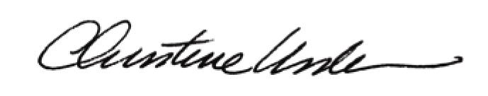

Date of Meeting: February 27, 2012 Title: Historic Officer

